The History of Sacred Heart of Jesus Parish
11. Other Priests Who Have Served the Parish

Two earlier articles reported on our pastors. Many other priests have also served the parish, as administrators, in-residence priests, or weekend assistants. Some served for brief periods, others for several years. This article highlights some of these priests.
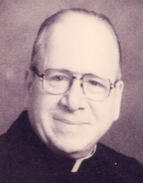
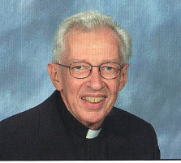
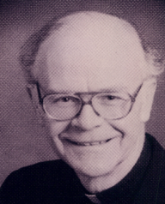
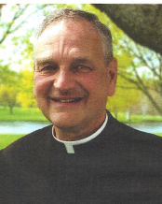
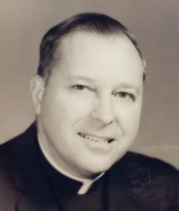
Administrators are appointed to oversee a parish when the pastorship is vacant, or during a pastor’s extended illness. Sacred Heart has had five administrators during its 95 years. Msgr. Pius Benincasa (left) administered the parish following Fr. Kleis’s death in February 1954 until Fr. Hall’s appointment in May. Msgr. Benincasa later served as an auxiliary bishop of Buffalo. Fr. Wilbur Yaeger (right) served as administrator from September 1967 to June 1968, during Fr. Zeitz’s final illness, until Fr. Richards’s appointment. Fr. David Scheider (left) was appointed during Fr. Kieber’s final illness in April 1990 until Msgr. Kern’s appointment in October. Msgr. Robert Zapfel (right) was appointed in October 2001 to assist Msgr. Kern during his illness and served until Fr. Mark Illig’s appointment in April 2002. Msgr. H. Jerome Sullivan (left) served as administrator following Fr. Mark Illig’s departure (January-April 2011) and again when Msgr. Sicari was ill (August – November 2011).
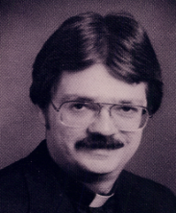
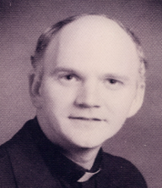
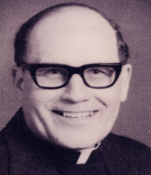
Several priests resided at Sacred Heart and helped on weekends while having other duties during the week. These included Fr. Thomas Taton (left), 1970-73 while teaching at Bishop Turner High School, Fr. Philip Noe (no photo), 1974-76 while serving as Diocesan Youth Director, Fr. Gary Kibler (center), 1976-77 and Fr. Loville Martlock (right), 1983-88, both while teaching at St. Mary’s High School.
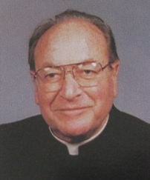
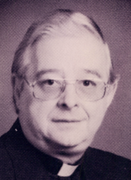
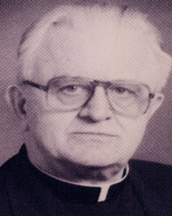
Also, some retired priests resided here and assisted on weekends: Fr. Walter Tomiak (left), 1979-80, Msgr. Valentine Welker (center), 1993-95, and Msgr. Arnold Schneider (right), 1995-98. Msgr. Welker, a leader in the charismatic movement, earned the respect and affection of the parish during his two years here, which were cut short by his death in an auto accident on June 1, 1995. The church was filled to overflowing for his funeral, celebrated by Bishop Edward Head. Msgr. Schneider, formerly pastor at St. Mary’s in Lancaster, was also very well-liked and was known for his good humor.
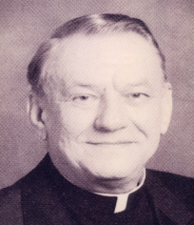
Many priests assisted on the parish weekends. Serving longest were Fr. Michael Weber (1937-47, no photo), chaplain for the Sisters of St. Francis in Williamsville and Msgr. Emil Bogumil (1980-90, right), a former U.S. Navy and Veterans Hospital chaplain and Diocesan director of hospital chaplains.
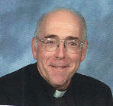
Sacred Heart even had an assistant pastor (now called a parochial vicar) on three brief occasions in its early years. Fr. James Kolb served from June to December 1927, enabling Fr. Ott to take a three-month vacation to Europe. Fr. Philip Schweir, who later became the first pastor at Nativity Parish in Harris Hill, served as assistant here from August 1934 to January 1935. Fr. Joseph Bach succeeded him, but the parish could not support two priests during the Depression years, and Fr. Bach was reassigned in March 1935 (he later served for many years as pastor at St. Mary’s in Swormville). We have not had an assistant pastor since. However, Fr. John Leising (left), senior parochial vicar at Nativity parish, assisted here while Msgr. Fred Leising served as our pastor (2011-2013).

