The History of Sacred Heart of Jesus Parish
3. The Parish Schools

The first existence of Sacred Heart School was from 1924 to 1939. The original school had only two classrooms, but eight grades of instruction were offered. There were 41 students when the school opened in 1924; ten years later, enrollment had grown to 71. The Sisters of St. Francis staffed the school. A convent was built for them in 1925, (see last month’s article).
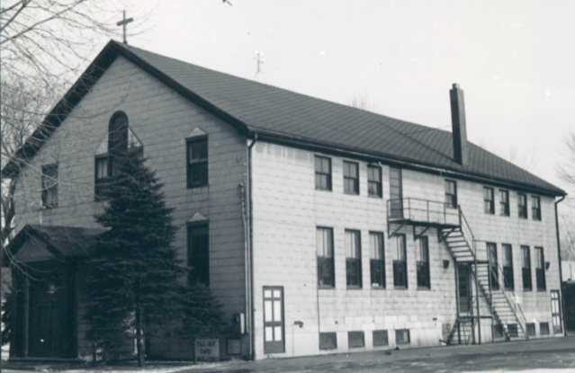
By the late 1930s, public school systems were providing bus transportation to students at many Catholic schools. But for some reason, bus transportation was not provided to Sacred Heart. Father Ott was given a large sedan by Schmitt’s Garage, and he tried to run a private bus service, but this was not workable. There were other problems as well. The parish was struggling financially through the Depression years of the 1930s, and the school was a big financial burden. Finally, there was a concern that the school’s water supply was not safe. Unsanitary water was thought to be a cause of polio, a big health concern at that time. As a result of all these problems, Father Ott closed the school in October 1939, only a few weeks after the school year began, to the disappointment of many parishioners. Many of our students then attended St. Mary’s in Lancaster. From 1939 to 1950, Sacred Heart had no school.
By 1950, all these problems were resolved, and Father Kleis reopened the school that fall. Four classrooms were constructed to house the eight grades – two grades per room. This arrangement continued for 15 years, until the new school opened in 1965. The Sisters of St. Francis returned to run the school, but no longer resided here. The parish grew rapidly after 1950, and the school was successful. By the early 1960s, the old school building was at capacity, and students were being turned away. A new school was needed.
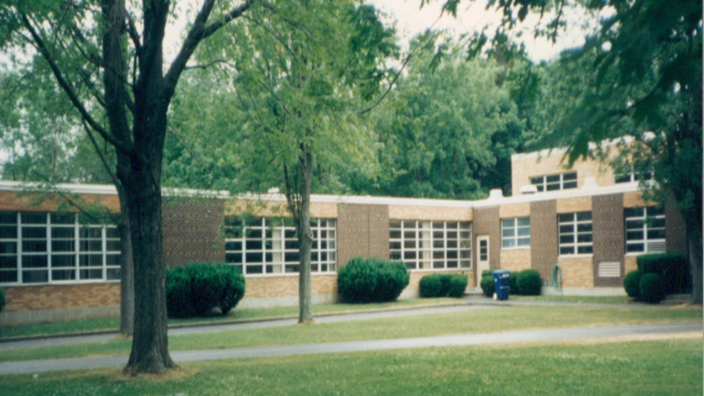
In early 1964, the Diocese approved construction of a new school, at a cost of $350,000. It was completed in time for the new school year in September 1965, when it opened with 200 students. Bishop James McNulty dedicated the new building in August 1965. The old school was then demolished.
Fall 1966 saw 210 students enrolled, but then enrollment began a slow but steady decline. By 1980, enrollment was down to 75. For fall 1980, a consolidation with Sts. Peter & Paul School in Depew was announced: kindergarten through fourth grade would be held at Sts. Peter & Paul, and fifth through eighth grade at Sacred Heart. This lasted three years. For fall 1983, the Sisters of St. Francis informed the parish they could no longer staff Sacred Heart School. Attempts were made to find other sisters who could take over, even if they supplied only one sister to act as principal. These attempts were unsuccessful, and Fr. Kieber reluctantly announced that our school would now be fully consolidated with Sts. Peter & Paul, with all classes held at their location. The two parishes would share the costs of running the school, in proportion to the number of students each had. Again, there was much disappointment with the closing of the school. Thus, the second existence of Sacred Heart School, from 1950 to 1983, ended with the final graduation on June 21, 1983.
The consolidated school at Sts. Peter & Paul lasted another 20 years, until rising costs and declining enrollment led to the closure of that school in June 2003.

