The History of Sacred Heart of Jesus Parish
2. The 1920s: Building the Parish

For almost three years from its start in June 1920, Sacred Heart was a mission parish served by Father Francis Scherer and his assistants at Our Lady Help of Christians. In April 1923, Bishop William Turner appointed our first resident pastor, Father Edward F. Ott. Father Ott, age 34, was a native of Lancaster and had been serving as an assistant at Sacred Heart parish in Buffalo. With a young, active resident pastor, life in the parish began to pick up.
We needed a place for our pastor to live. The adjoining property to the east, known as
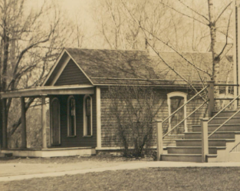
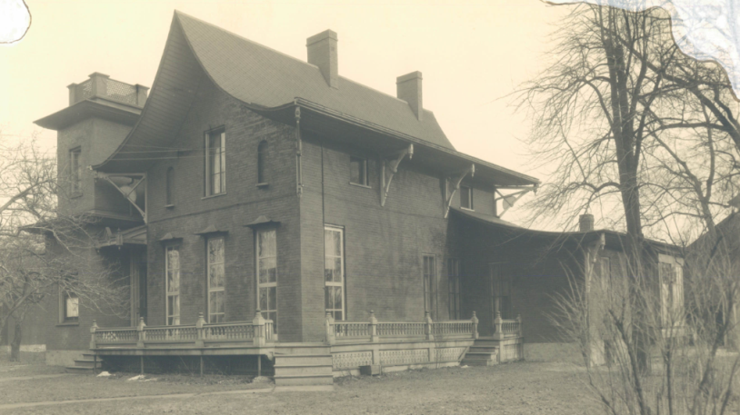
the Staub property, was purchased for $2,400 in May 1923. It had a small cottage (see photo) that was quickly remodeled, and Fr. Ott moved in. That proved to be a temporary solution. In October 1923, the next property to the east, containing the present rectory and a large barn, was bought for $12,000. The land extended back to Ellicott Creek, where eventually the cemetery would be. The rectory had been built in the 1870s by Dr. Theodore Lewis, a Buffalo dentist, and featured Japanese design, including its distinctive curved roof (photo).
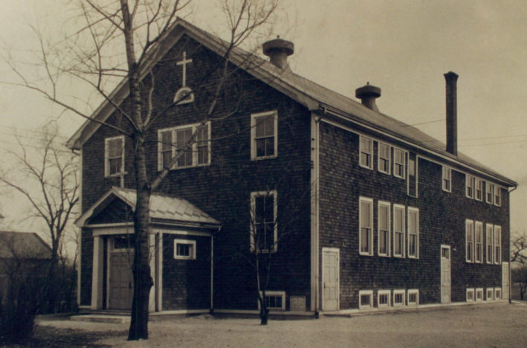
In 1924, the parish school was constructed. The small cottage was moved to the rear of the property, and the school was built east of the church. Fr. Ott and parishioners did most of the work to prepare the site and build the foundation. The school (photo) had two classrooms at the rear of the main floor, with a large social space at the front. The second floor was the parish hall, complete with kitchen facilities. The basement could also be used for social events. The school opened in Fall 1924 with 41 students, staffed by the Sisters of St. Francis.
Now we needed a place for the sisters to live. The cottage was expanded and remodeled to create a convent (photo); the sisters moved in in September 1925.
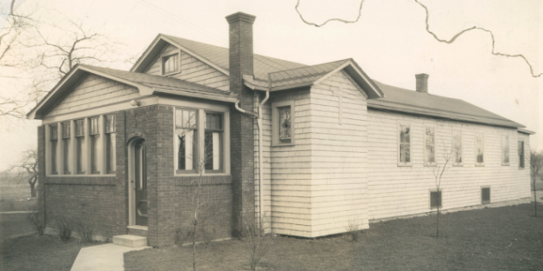
While the building program seemed complete, that was not the case. In July 1926, Fr. Ott announced plans to build the shrines – one dedicated to the Immaculate Conception and one to the Eucharistic Heart of Jesus. The shrines were completed in Spring 1927; Bishop William Turner dedicated the shrines on May 30 (more on the shrines in a future article).
The 1920’s were a time of building the parish. In the first four years after Fr. Ott’s appointment as pastor, two more land parcels were acquired; the school was built; the cottage and the rectory were acquired; the cottage was remodeled into a convent after brief service as Fr. Ott’s home; and the shrines were constructed. Of these, only the rectory and the shrines remain today.
Coupled with the debt from building the church, the parish owed $49,500 at the end of 1929. This was a big debt when the annual collection was less than $3,000. The stock market crash of 1929 led to the Great Depression through most of the 1930s, and that brought many financial challenges to the parish (more on that in a future article).

