The History of Sacred Heart of Jesus Parish
4. The Parish Churches

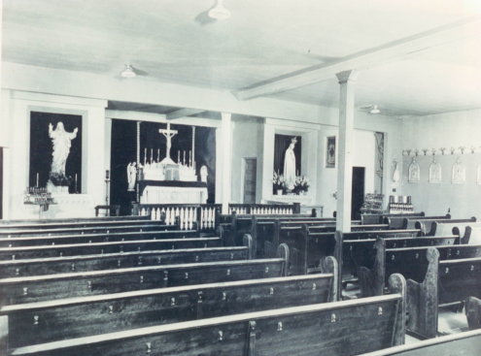
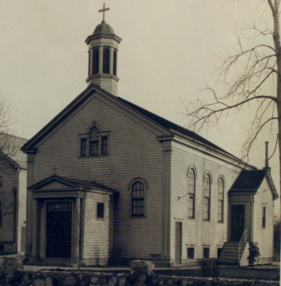
Our original church (photo), built in 1920, seated about 100 people. As the parish grew, it became more and more crowded. By 1940, it was clearly too small. But the parish school had closed in 1939, and that building was vacant. The two classrooms were eliminated, and the first floor was converted into a church that could seat 250 (photo). This solved the problem for the next ten years.
In 1950, the school was reopened, and the original church had to be used again. That building was already too small in 1940, and the parish now had 300 families. The temporary solution was to schedule five Masses on Sunday mornings (there were no Saturday Masses at this time). Two years later, we had 390 families. A new church was desperately needed. Planning and fund raising began in 1952. But in February 1954, our pastor, Fr. Earl Kleis, died suddenly of a heart attack at age 53, and plans for a new church were put on hold.
The suburbs were growing rapidly, as many people moved out of the city of Buffalo after World War II. Before appointing a new pastor, in May 1954 the Diocese decided to establish a new parish in Harris Hill – Nativity of the Blessed Virgin Mary. The split reduced Sacred Heart to 237 families, and Sunday Masses were reduced to four.
But Nativity had no facilities as yet. In October 1954, after a few months of meeting in temporary locations, it was decided that Nativity would share Sacred Heart’s facilities until its combination church-school building could be constructed. To accommodate this, the second floor of Sacred Heart’s school building was remodeled into a second church. Six Sunday Masses were scheduled, two in the church and four in the upper school hall. When Nativity’s building was ready in November 1955, we went back to four Sunday Masses, but continued to use the upper school hall for all but the 8:00 A.M. Mass.
By the end of 1957, the parish had grown to 331 families, adding nearly 100 in the three years since the split. It was time for a new church. In January 1958, the Diocese gave permission to build a new church to seat 450, estimated to cost $200,000. In June, 75 men of the parish gathered to clear the land at the west end of the property, in preparation for the new building. Meanwhile, many fund-raising activities were held to raise money for the new church. Roast beef dinners were especially popular and successful, with about 1,200 dinners served on each occasion.
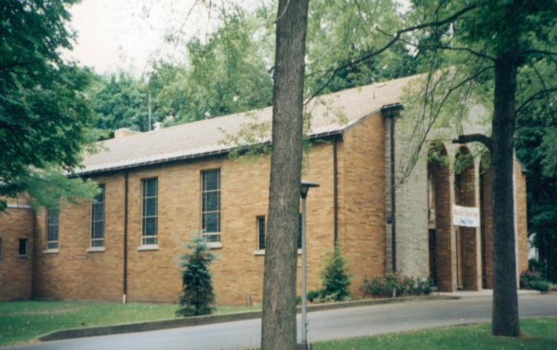
Construction began in July 1958 and was completed late the following summer. Auxiliary Bishop Leo Smith dedicated the new church on September 27, 1959. The project came in under budget, costing $187,500. We already had raised $117,000, leaving a debt of $70,000. By the end of 1962, the parish had grown to 476 families and the church debt was paid off.
Father Edward Ott had served as our first resident pastor, from 1923 to 1941. He was then reassigned to a parish in Orchard Park. But Fr. Ott always had a great love for Sacred Heart. When he died in 1960, he left his entire estate – over $80,000 – to Sacred Heart. This was a big help in paying off the debt for the new church.
Thus, our church has had four locations: the original church (1920-40 and 1950-59), the first floor of the old school (1940-50), the second floor of the old school (1954-59), and our current building since 1959. This building should serve us well for many years to come.

